SUPPLEMENTARY FIGURES
Multiple Cold Tolerance Trait Phenotyping Reveals Shared Quantitative Trait Loci in Oryza sativa
Authors: Naoki Shimoyama, Melineeh Johnson, André Beaumont, Michael Schläppi*
Department of Biological Sciences, Marquette University, Milwaukee, WI, United States

*Correspondence: michael.schlappi@marquette.edu

Supplementary Fig. S1 Quantile-Quantile (Q-Q ) plots for all cold tolerance trait GWAS mapping. Plots were created using the RDP1 GWAS mapping pipeline (McCouch et al. 2016). Divergence of SNPs from expected (significance cutoff) is apparent at -log10(p)> 4 for all plots.

Supplementary Fig. S2 Multiple Trait QTL (qMT) Biological Processes enrichment tree map. GO term enrichment analysis of all genes within qMT QTL is shown. GO term similarity was calculated using simRel scores, and a tree map for Biological Processes was constructed using REVIGO.

Supplementary Fig. S3 Multiple Trait QTL (qMT) Cell Component enrichment tree map. GO term enrichment analysis of all genes within qMT QTL is shown. GO term similarity was calculated using simRel scores, and a tree map for Biological Processes was constructed using REVIGO.

Supplementary Fig. S4 Multiple Trait QTL (qMT) Molecular Function enrichment tree map. GO term enrichment analysis of all genes within qMT QTL is shown. GO term similarity was calculated using simRel scores, and a tree map for Biological Processes was constructed using REVIGO.

Supplementary Fig. S5 Filtered Gene List Biological Processes enrichment tree map. GO term enrichment analysis for 71 filtered genes within qMT QTL is shown. GO term similarity was calculated by simRel scores and a tree map for Biological Processes was constructed by REVIGO.

Supplementary Fig. S6 Filtered Gene List Cell Component enrichment tree map. GO term enrichment analysis for 71 filtered genes within qMT QTL is shown. GO term similarity was calculated by simRel scores and a tree map for Cell Component was constructed by REVIGO.

Supplementary Fig. S7 Filtered Gene List Molecular Function enrichment tree map. GO term enrichment analysis for 71 filtered genes within qMT QTL is shown. GO term similarity was calculated by simRel scores and a tree map for Molecular Function was constructed by REVIGO.

Supplementary Fig. S8 Multiple Trait (qMT) QTL + Tolerant & Sensitive Cluster QTL Biological Process enrichment map. GO term enrichment analysis of 159 filtered genes within qMT + cluster specific QTL is shown. GO term similarity was calculated by simRel scores and a tree map for Molecular Function was constructed by REVIGO.

Supplementary Fig. S9 Multiple Trait (qMT) QTL + Tolerant & Sensitive Cluster QTL Cell Component enrichment map. GO term enrichment analysis of 159 filtered genes within qMT + cluster specific QTL is shown. GO term similarity was calculated by simRel scores and a tree map for Molecular Function was constructed by REVIGO.

Supplementary Fig. S10 Multiple Trait (qMT) QTL + Tolerant & Sensitive Cluster QTL Molecular Functon enrichment map. GO term enrichment analysis of 159 filtered genes within qMT + cluster specific QTL is shown. GO term similarity was calculated by simRel scores and a tree map for Molecular Function was constructed by REVIGO.

Supplementary Fig. S11 Model for functional associations of candidate term clusters. Shown is one possibility of how candidate genes from different GO term clusters may control cold tolerance through the ABA signaling pathway. Alternative models are possible (not shown).

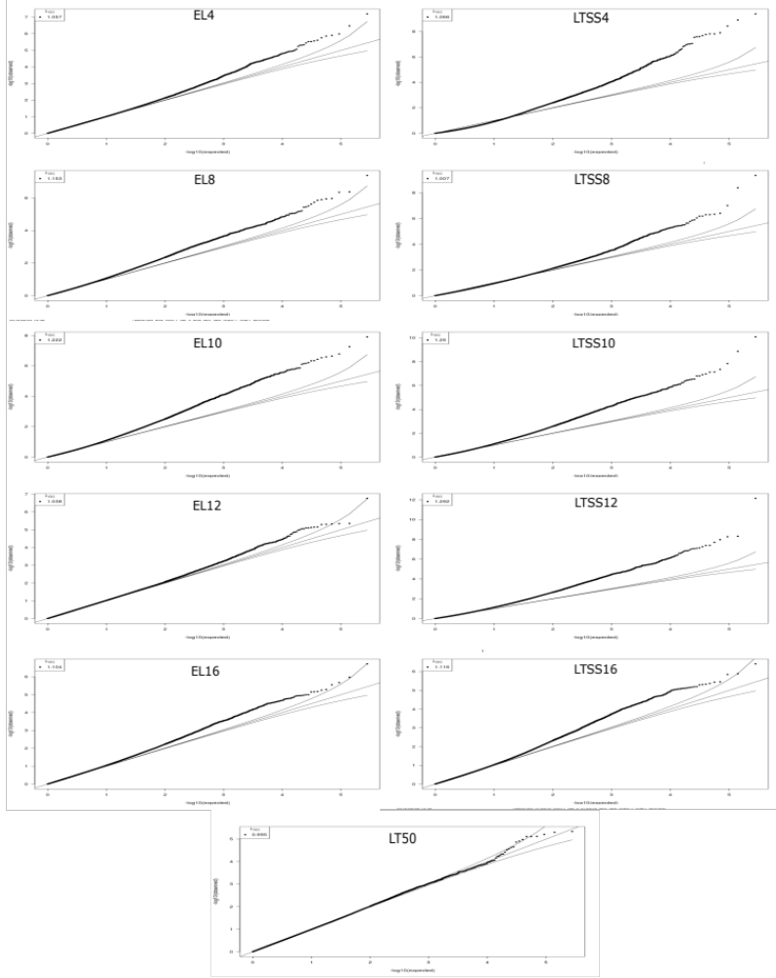
Supplementary Fig. S1 Quantile-Quantile (Q-Q ) plots for all cold tolerance trait GWAS mapping. Plots were created using the RDP1 GWAS mapping pipeline (McCouch et al. 2016). Divergence of SNPs from expected (significance cutoff) is apparent at -log10(p)> 4 for all plots.
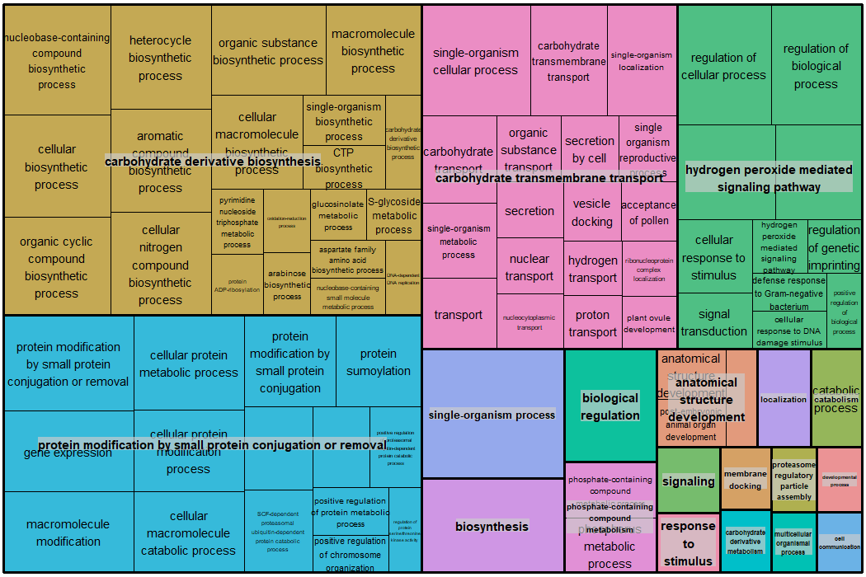
Supplementary Fig. S2 Multiple Trait QTL (qMT) Biological Processes enrichment tree map. GO term enrichment analysis of all genes within qMT QTL is shown. GO term similarity was calculated using simRel scores, and a tree map for Biological Processes was constructed using REVIGO.

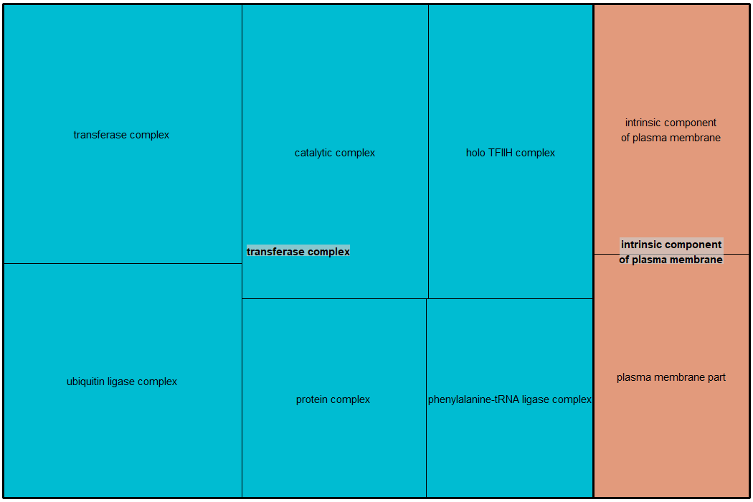
Supplementary Fig. S3 Multiple Trait QTL (qMT) Cell Component enrichment tree map. GO term enrichment analysis of all genes within qMT QTL is shown. GO term similarity was calculated using simRel scores, and a tree map for Biological Processes was constructed using REVIGO.
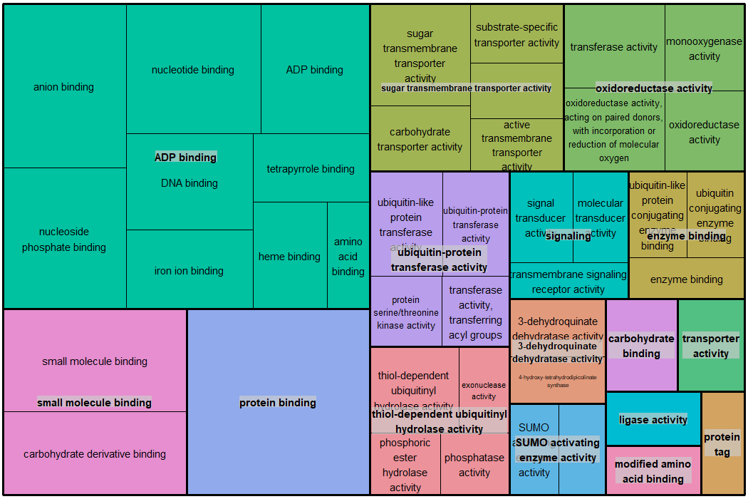
Supplementary Fig. S4 Multiple Trait QTL (qMT) Molecular Function enrichment tree map. GO term enrichment analysis of all genes within qMT QTL is shown. GO term similarity was calculated using simRel scores, and a tree map for Biological Processes was constructed using REVIGO.
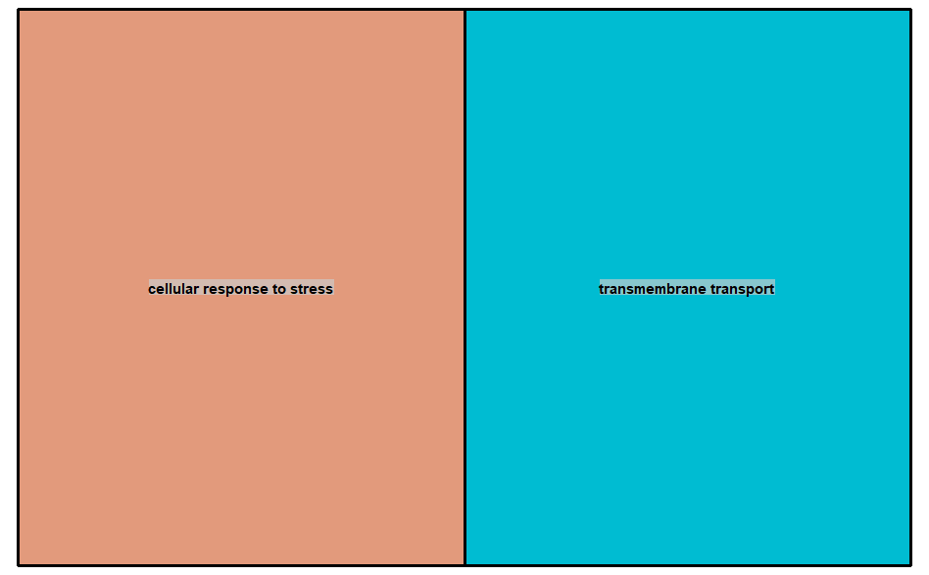
Supplementary Fig. S5 Filtered Gene List Biological Processes enrichment tree map. GO term enrichment analysis for 71 filtered genes within qMT QTL is shown. GO term similarity was calculated by simRel scores and a tree map for Biological Processes was constructed by REVIGO.

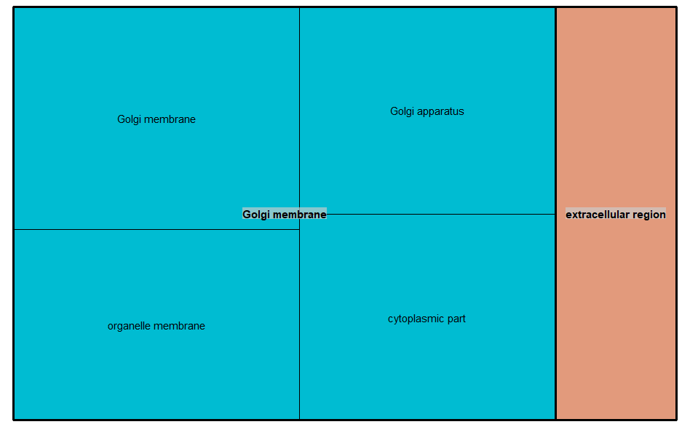

Supplementary Fig. S6 Filtered Gene List Cell Component enrichment tree map. GO term enrichment analysis for 71 filtered genes within qMT QTL is shown. GO term similarity was calculated by simRel scores and a tree map for Cell Component was constructed by REVIGO.

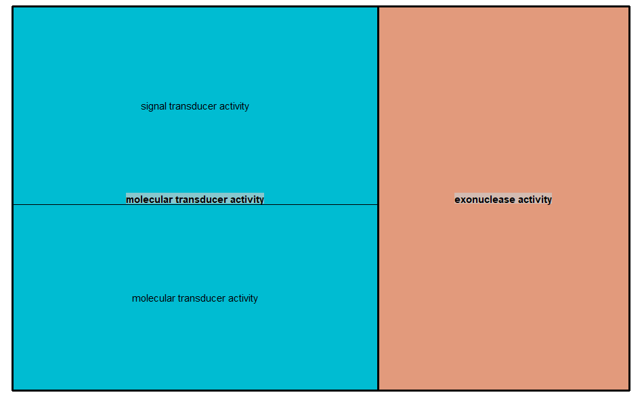
Supplementary Fig. S7 Filtered Gene List Molecular Function enrichment tree map. GO term enrichment analysis for 71 filtered genes within qMT QTL is shown. GO term similarity was calculated by simRel scores and a tree map for Molecular Function was constructed by REVIGO.

Supplementary Fig. S8 Multiple Trait (qMT) QTL + Tolerant & Sensitive Cluster QTL Biological Process enrichment map. GO term enrichment analysis of 159 filtered genes within qMT + cluster specific QTL is shown. GO term similarity was calculated by simRel scores and a tree map for Molecular Function was constructed by REVIGO.

Supplementary Fig. S9 Multiple Trait (qMT) QTL + Tolerant & Sensitive Cluster QTL Cell Component enrichment map. GO term enrichment analysis of 159 filtered genes within qMT + cluster specific QTL is shown. GO term similarity was calculated by simRel scores and a tree map for Molecular Function was constructed by REVIGO.

Supplementary Fig. S10 Multiple Trait (qMT) QTL + Tolerant & Sensitive Cluster QTL Molecular Functon enrichment map. GO term enrichment analysis of 159 filtered genes within qMT + cluster specific QTL is shown. GO term similarity was calculated by simRel scores and a tree map for Molecular Function was constructed by REVIGO.

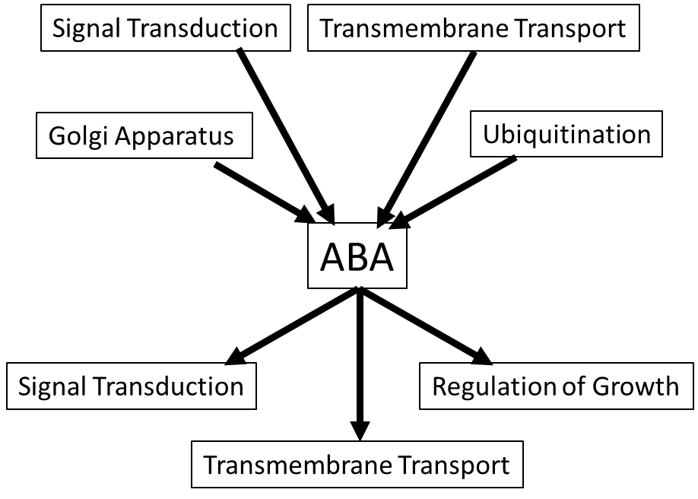
Supplementary Fig. S11 Model for functional associations of candidate term clusters. Shown is one possibility of how candidate genes from different GO term clusters may control cold tolerance through the ABA signaling pathway. Alternative models are possible (not shown).

